AI FitTrack Project Design
  - Phase 3

This design specification documents the actual architecture, data model, API contracts, request sequence, security controls and Gemini integration implemented in the uploaded backend.
Field | Value
Project | AI FitTrack
Submission | SmartBridge Naan Mudhalvan
Team ID | SWTID-2026-8100
Team size | 4
College | DRBCCC Hindu College
Department | B.Sc. Computer Science with Artificial Intelligence
Academic Year | 2024–2027
Faculty Guide | Prof. D Saraswathy
Submission Date
Team Leader | Parthiban M (NM ID: 28538B1DB05060E8D804CDAA88169909, Reg: 222401226)
Team Members | Naveen J (NM ID: 53C2DC1753C6DFDAF8649841B4630C80, Reg: 222401223); Nidesh N S (NM ID: FDE55A8DA9135F6AB7347C01AD1B8A17, Reg: 222401224); Nithish Kumar P (NM ID: BFBD9AD8CEC72229F374877DB82CC0B8, Reg: 222401225)
Project scope | Backend-only REST API
Technology | Node.js, Express.js, MongoDB, Mongoose, JWT and Google Gemini AI
Source baseline | Latest uploaded backend ZIP and supplied verification evidence
Document status | Submission-ready verified technical documentation with complete academic details

Prepared for academic evaluation. Secrets, credentials, private environment files and unverified claims are excluded.

Document contents
1. Architecture
2. Component design
3. Database design
4. API design
5. Security and AI design
6. Error and configuration design

Architecture overview
The project uses an MVC-inspired layered backend. Express routes receive requests, middleware verifies identity, validation utilities normalize inputs, controllers coordinate use cases, Mongoose models persist data and service modules encapsulate JWT and Gemini behavior. The REST response is the view returned to the API consumer.
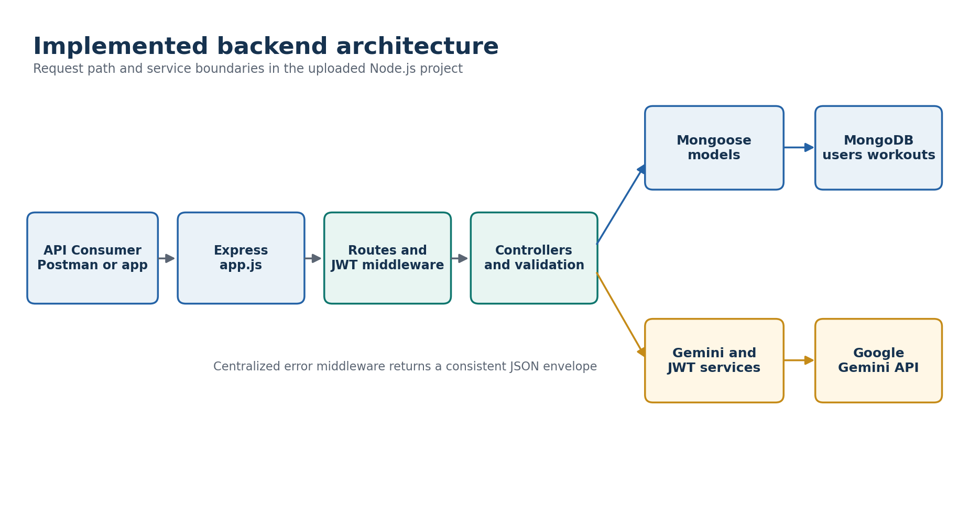
Figure 1 Implemented backend components and external dependencies

Component responsibilities
Layer | Files | Responsibility
Gateway | app.js, server.js | Load configuration, CORS and body parsing; connect database; mount routes; start and stop server safely.
Routes | routes/*.js | Map HTTP methods and paths to controller functions; apply JWT protection to protected groups.
Middleware | middleware/*.js | Authenticate Bearer tokens, load the current user and produce centralized 404 and error responses.
Controllers | controllers/*.js | Execute authentication, workout and AI use cases and return standard responses.
Models | models/User.js, models/Workout.js | Define document shape, validation, hooks, indexes and safe serialization.
Services | services/jwtService.js, geminiService.js | Sign and verify JWTs; generate structured Gemini content with timeout and retry handling.
Utilities | utils/*.js | Input validation, safe async handling, API errors and response helpers.
Verification | tests/, postman/ | Automated behavior checks and ordered manual request collection.

Database design
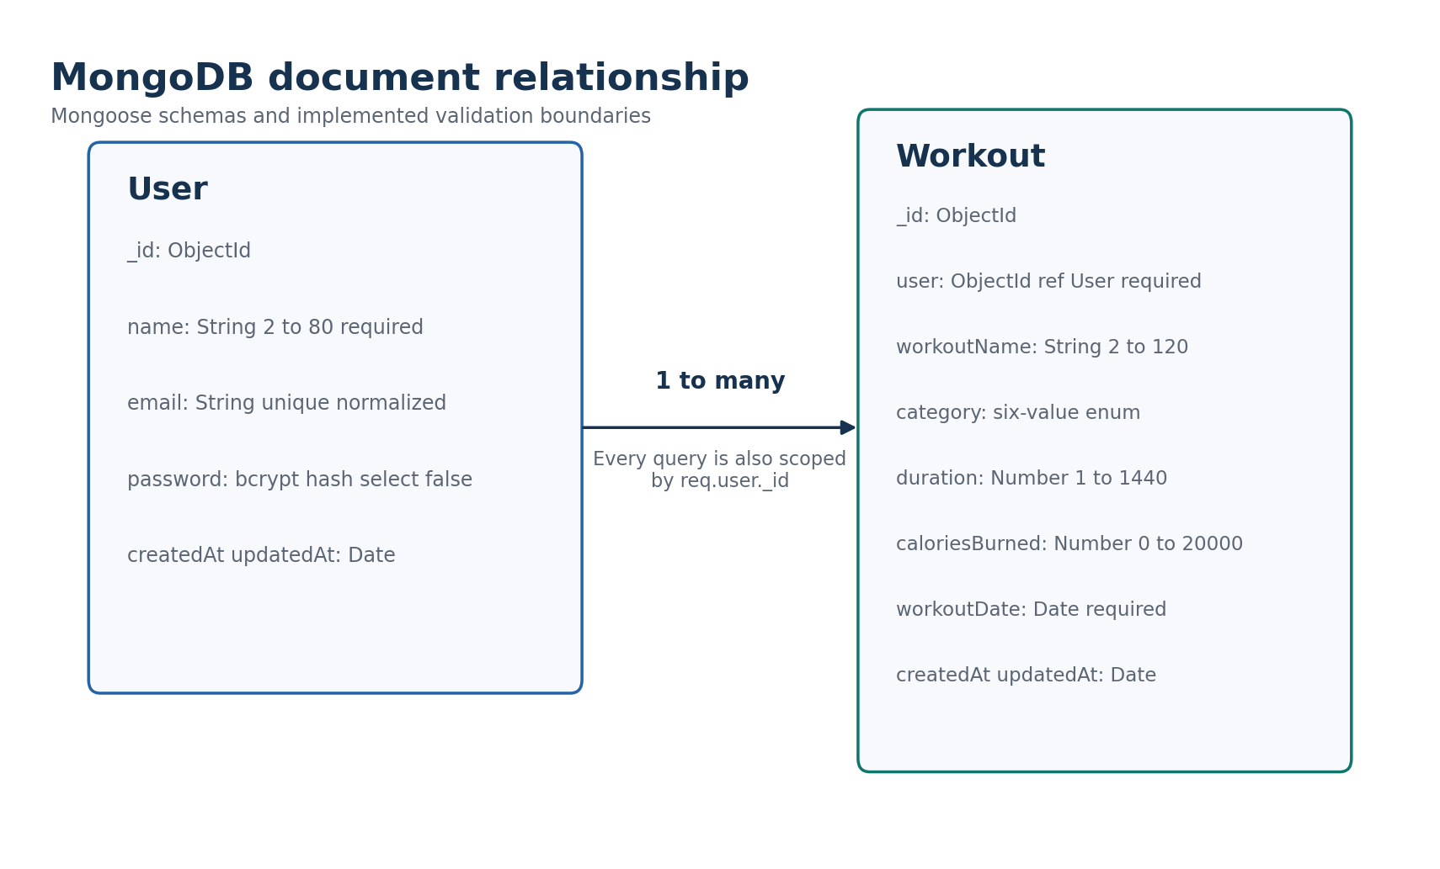
Figure 2 User to Workout one-to-many document relationship
User field | Type | Constraint
_id | ObjectId | MongoDB primary identifier
name | String | Required, trimmed, 2-80 characters
email | String | Required, unique, lowercase, validated
password | String | Required, bcrypt hash, select false
createdAt / updatedAt | Date | Automatically maintained

Workout field | Type | Constraint
_id | ObjectId | MongoDB primary identifier
user | ObjectId ref User | Required, indexed owner
workoutName | String | Required, trimmed, 2-120 characters
category | String | Required, six-value enumeration
duration | Number | Required, 1-1440 minutes
caloriesBurned | Number | Required, 0-20000
workoutDate | Date | Required
createdAt / updatedAt | Date | Automatically maintained

Protected request design
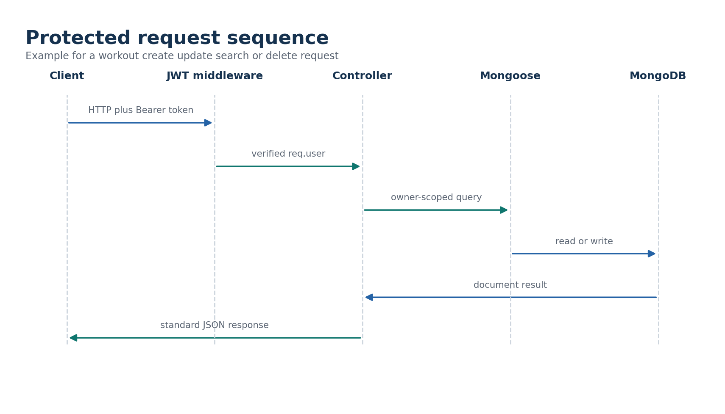
Figure 3 JWT verification and owner-scoped data access sequence

API contract catalog
Method | Endpoint | Access | Purpose | Main statuses
GET | /api/health | Public | Service health and runtime metadata | 200
POST | /api/auth/register | Public | Create user and issue JWT | 201, 400, 409
POST | /api/auth/login | Public | Verify credentials and issue JWT | 200, 400, 401
GET | /api/auth/email-available | Public | Check normalized email availability | 200, 400
GET | /api/auth/profile | JWT | Return authenticated user profile | 200, 401
POST | /api/workouts | JWT | Create an owner-scoped workout | 201, 400, 401
GET | /api/workouts | JWT | List history and optional filters | 200, 400, 401
GET | /api/workouts/search | JWT | Search by name, category or UTC date | 200, 400, 401
GET | /api/workouts/:id | JWT | Read one owned workout | 200, 400, 404
PUT | /api/workouts/:id | JWT | Update allowed workout fields | 200, 400, 404
DELETE | /api/workouts/:id | JWT | Delete one owned workout | 200, 400, 404
POST | /api/ai/workout-recommendation | JWT | Generate structured workout plan | 200, 400, 429, 5xx
POST | /api/ai/fitness-insights | JWT | Generate submitted or database-derived insights | 200, 400, 429, 5xx

Standard response envelopes
Success
{
"success": true,
"message": "Operation completed",
"data": { "...": "endpoint-specific payload" }
}
Failure
{
"success": false,
"message": "Validation failed",
"errors": [{ "field": "fieldName", "message": "Reason" }]
}

Security design
- Passwords are hashed in a Mongoose pre-save hook using bcrypt with a cost factor of 12.
- The password field is select:false and removed again during JSON and object serialization.
- JWTs carry the user id in sub, use issuer ai-fittrack-api and default to a one-day expiry unless configured.
- Protected middleware verifies the token, validates the ObjectId and reloads the user from MongoDB.
- Workout queries combine the requested identifier or filter with req.user._id.
- CORS allows configured origins, non-browser clients and the methods needed by the API.
- The JSON body limit is 1 MB and malformed JSON is converted to a 400 response.
- AI requests have a per-process default limit of 10 requests per user per minute.

Gemini integration design
The Gemini service builds constrained fitness prompts and requests JSON matching explicit schemas. Recommendation output includes a plan, weekly schedule, experience guidance, tips, recovery, safety and motivation. Insight output is based only on submitted metrics or the caller's owner-scoped records.
Control | Implemented behavior
Configuration | GEMINI_API_KEY is required; model, timeout and retry parameters are configurable.
Default model | gemini-3.6-flash in the uploaded source and supplied live evidence.
Timeout | 30 seconds by default, capped at 120 seconds.
Retries | Default 3 attempts, maximum 5, exponential backoff, jitter and Retry-After support.
Response validation | Extract and parse a JSON object, then reject empty, malformed or incomplete responses.
Safe failure | Normalize missing key, bad key, unavailable model, rate limit, timeout and provider errors.

Environment configuration design
PORT=<local port>
MONGO_URI=<MongoDB connection string>
MONGO_USER=<optional separate username>
MONGO_PASSWORD=<optional separate password>
MONGO_AUTH_SOURCE=admin
JWT_SECRET=<strong private random secret>
JWT_EXPIRES_IN=1d
CLIENT_URL=http://localhost:5173
GEMINI_API_KEY=<private Google Gemini key>
GEMINI_MODEL=gemini-3.6-flash
GEMINI_TIMEOUT_MS=30000
GEMINI_MAX_ATTEMPTS=3
AI_RATE_LIMIT_PER_MINUTE=10
The values above are configuration names and safe placeholders only. The private .env file is intentionally absent from the submission.

Items requiring student confirmation
Pending item | What to provide
Repository | Insert the final public GitHub repository URL after upload.
Deployment | Insert the deployed API base URL if the evaluator requires a hosted demonstration.

